**dAR**

**(Dilute Aqua Regia)**

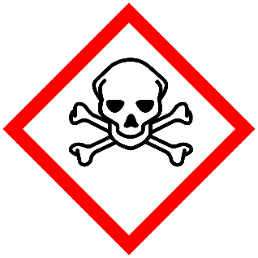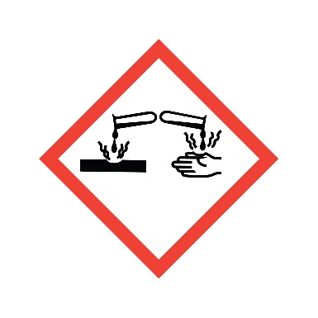

**Danger**

Causes severe burns in contact with skin or eyes.

**Composition**

**Hydrochloric Acid + Nitric Acid + DI Water**